|  |
| --- |
| Design Project  Into to Networks - LIS4482  Patrick Duke, Andrew Vargas, Jamel Douglas, and Alex Hughes |

Executive Summary

In the following proposal, we hope to outline the details for the data network required for the new office of The Everglades Foundation. We have addressed the situation in terms of building layout, technology already owned, and the company needs in order to establish an efficient/cost effective design. This will include the utilization of the space to include a directors office, 2 split offices for 4 full time staff, a computer classroom for training purposes and other work purposes, and an intern/part time work room. A space has also been allocated to be used as a tech room to meet the needs of the data network.

Written Description

The diagrams below (Appendix A and B) show the planned network design for the new office. This design has been reached through careful consideration of cost and workflow needs.

In today’s world, wireless networks have become an extremely useful tool in any organization's network. They provide flexibility and cost reduction. This has led to the decision to have a primarily wireless network. The fact that there are 5 part time workers and 35 interns/volunteers also influenced this decision. Providing 40 separate work stations for each of these workers would cost way too much and be an unnecessary expense. Allowing these workers to bring their own devices allows for the flexibility to bring in the required amount of workers for any given tasks.

After doing research into small business routers, we have decided to use the Synology RT2600AC. This is a great router for an affordable price and comes with a wide variety of security features. VPN service is also available to allow access to the network from an outside location. We have decided to purchase 3 to adequately cover all of the office work areas. The diagrams will show their placement in the facilities. You may notice that only one of these routers will connect to the internet/cloud. This is to better secure the network from outside threats.

Now although the expectation is that most workers will use their personal devices, the previous occupant has left some technology that we feel can be utilized to help reduce cost. 18 computers of various models and operating systems will be cataloged and given a performance rating. The top 7 will be used with the other 11 going into storage in case the company finds a need for them. The 7 best will be used for the following: 1 PC for the directors office, 4 for each full time staff member, 1 in the training room for training purposes (most lilley for a projector, but left to the organizations discretion) and 1 in the IT room to monitor and manage the network. Just to clarify, the wireless routers allow for the director and full time staff to bring their personal computers in to do work, but the PCs we have available provide a convenience for these workers if they want it. It should be noted that the operating system on all the computers is outdated and needs to be updated. We will budget for the 7 used in this design with a notice that if the organization wishes to use the computer in storage, those operating systems will need to be updated as well. We have chosen Windows 10 because of its reliability, speed, and security features.

The server services required for storing documents and using email will be outsourced to cloud based services. This is a very popular cost reducing technique used by small businesses on a budget and is probably the most cost saving strategy in the entire design. Security is an issue that might be a concern with this technique, but the policies stated in the security section below will adequately address this issue.

A device that will need to be purchased is the office printer. A printer is crucial in any workplace environment. We have also connected the printer in a way that allows any device connected to the network from anywhere in the office (or even outside it) will be able to use the printer.

The organization has a need for workers to make donation calls. Because of this we have gone to the liberty of adding 20 USB communication headsets to the list of items to be purchased. These headset will be kept in either the training room, or storage and be given out on a need basis. It should also be noted that we have found a very affordable headset and should the need arise to get more it will not impact the budget drastically.

The last part of the design that needs to be discussed is the cabling that will be used to connect all of the network devices that have been discussed. We have decided to use Cat 5e Ethernet, which is an affordable and popular cable used in today’s networks and will absolutely meet the needs of the organization.

To conclude, We believe the design laid out will meet the workflow needs of the organization while also being cost effective.

Network Policies

There should be a local DNS server to serve domain resolution for the network. The function of this server is to resolve domain names to IP addresses of local and external services. This will be running on our external router.

The plan is to have a majority of IP addresses dynamically assigned with a few devices having a static IP address. For this to be accomplished, there needs to be a DHCP Server on the local network to hand out dynamically assigned IP addresses. This will be running on the external router. The three routers will have a static IP address.

There should be a VPN server setup to allow for remote connections to the network. This will allow for the employees and interns to connect to the network so they can do remote work. This VPN will be running on the external router.

The network needs some kind of monitoring solution coupled with intrusion protection. This allows for the network administrator to accurately see what is going on in the network and to also monitor any unauthorized access. Simple monitoring can be done with a SNMP server. These services will be running on the external router.

The cloud server will be maintained by the company providing the services. The local network will be maintained by one of the full time employees. This employee will also serve as the liaison with the cloud vendor for issues and any general maintenance.

Security Policies

Security priorities include protection of the company, its team members and its stakeholders. The measures put in place to protect our assets are both physical and logistical. These policies are crucial to the survival of the NPO and failure to comply with policy and proper procedures will result in immediate appropriate corrective action which may result in separation with the company.

Our location is located in a secure office building with a reception desk and armed security guard.

Our IT room is a secure Deadbolted room with Authorized limited access only

We will also have basic security training, informing our team members some of the basics for creating passwords, when to perform system updates, and safe practices such as not to not open attachments from any sources you’re not familiar with.

We will be using the Synology RT2600AC router which comes equipped with built in IvP4 and IvP6 firewalls, Intrusion Prevention Systems, Intrusion Detection Systems and a VPN. These features are only accessible through secure QuickConnect with ID and password and can only be connected via Terminal in the IT room. All other ports trying to connect to QuickConnect custom url will be blocked.

Disaster Recovery Policy

Disaster Recovery Policies

Our NPO will have strong fault tolerance, to ensure that in the event that there is equipment failure, we’re able to switch out broken components with our backups continue operations.

Some of these components may include but are not limited to backup tape drives, spare hard drives, power supplies and network links.

The following Disaster measures are included in our Disaster Policy

-RAID 1 Solutions via hardware- “Redundant Array of Independent Disks is the concept of storing redundant data on additional drives in case one drive in the RAID solution should fail.” Disk Mirroring duplicates the data and allows the computer to access the data from both drives, that way if a harddrive were to fail, we wouldn’t lose any data.

Tape Rotation and Offsite Storage- Use tape rotation with backup software and store the backup tapes somewhere offsite in case of a catastrophic event such as a fire.

-Network Link- protected through analog modems in the router

Weekly checks of data storage and restoration are tested on a separate environment.

When it comes to equipment, our recovery plan includes having only essential spare components to help save on cost. At our current magnitude, we believe that current methods of disaster recovery are sufficient to help prevent the loss of any important data given that we lost it due to lack of preparation during a catastrophic failure.

Keeping our data automatically saved into the cloud and then transferred to a physical device such as an external harddrive is also another way our NPO is protecting our data.

Backup cloud storage service being used is Idrive Business, $1799.40 a year for 5TB storage. It also comes with 2 factor authentication which is also an extra added feature for security.

Budget

|  |  |  |  |  |  |  |  |
| --- | --- | --- | --- | --- | --- | --- | --- |
| Type of Expenditure | Amount Budgeted | Amount | Amt. Remaining | Notes |  |  |  |
|  |  |  |  |  |  |  |  |
| Installation Fees | 5,000 | 5,000 | 12,684 | Use of Volunteers Cuts back on installation costs |  |  |  |
| Equipment (Existing) |  |  |  |  |  |  |  |
| CRT Screen | 1,080 | 1,080 | 11,604 | (9 Count) |  |  |  |
| LCD Screen | 1,350 | 1,350 | 10,254 | (9 Count) |  |  |  |
| Pentium III CPU | 1,350 | 1,350 | 8,684 | (9 Count) |  |  |  |
| Celerons CPU | 1,800 | 1,800 | 7,104 | (9 Count) |  |  |  |
| Microsoft Office Suite | 350 | 350 | 6,754 | (Assumed Number of units) |  |  |  |
| Corel Word Perfect | 500 | 500 | 6,254 | (Assumed Number of units) |  |  |  |
| Equipment (Procured) |  |  |  |  |  |  |  |
| Synology RT2600AC | 600 | 600 | 5,654 | (3 Count) |  |  |  |
| Koss CS95 USB Headset | 840 | 840 | 4,814 | (35 Count) |  |  |  |
| Canon Printer | 90 | 90 | 4,724 |  |  |  |  |
| Microsoft Office Suite | 470 | 470 | 4,254 | (7 Count) |  |  |  |
| Windows 10 | 280 | 280 | 3,974 | (7 Count) |  |  |  |
| Ethernet Hubs | 200 | 200 | 3,774 | (2 Count) - Install Not Included |  |  |  |
| iDrive Subcription | 1800 | 1800 | 1,974 | (Yearly) |  |  |  |
| Cat 6 Cable | 220 | 220 | 1,754 | (1,000 Ft.) |  |  |  |
| Fault Tolerance |  |  |  |  |  |  |  |
| Seagate 5TB HDD | 1,610 | 1,610 | 144 | (14 Count) |  |  |  |
| 10TB HD | 144 | 144 | 0 | (Off-Site) |  |  |  |
| Total | $17,684 | $17,684.0 |  |  |  |  |  |

The amount of materials we needed to acquire is reduced by the efficiency/dynamic abilities of the router we chose. This wireless based network also saves a lot of work with installation and maintenance. Having the volunteers/interns bring their own devices and working through headsets saves a daunting amount of money up-front; however, this means more must be spent on a valid, well-endowed cloud-based system.

Most devices can be set-up and operated by the employee’s themselves and can be utilized without a technician--saving money on installation fees. Since we are unsure about the amount of software on the desktop computers left behind by the previous tenant, we purchased software for all desktop computers that are in use. This includes Windows10 and Microsoft Office Suite for 7 computers. These are necessary items for an NPO. To save money on paper and to encourage waste-conscious behavior, only one printer was procured.

Appendix A: Physical Network Diagram

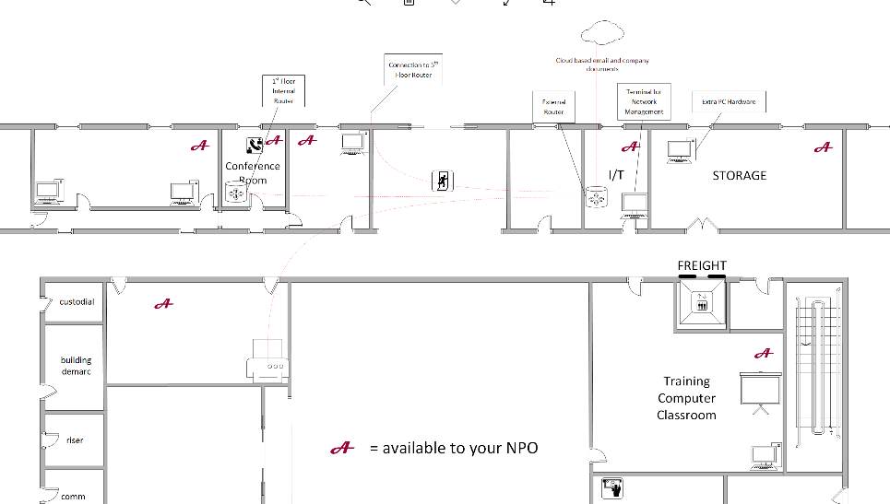

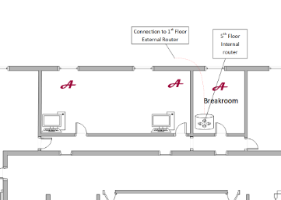

Appendix B: Logical Network Diagram

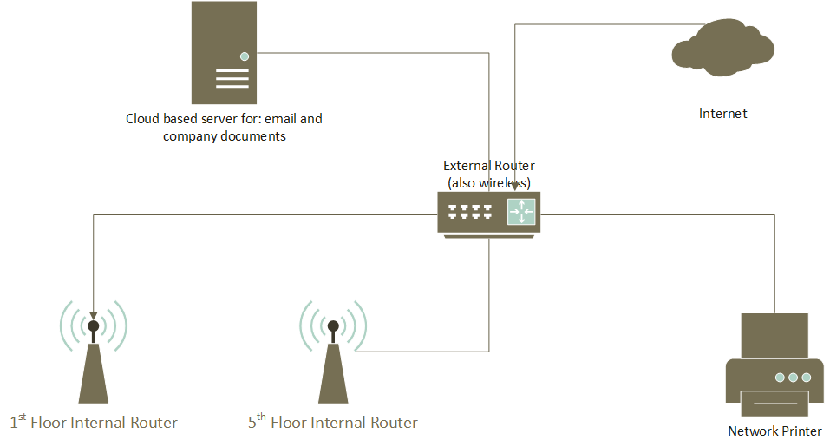

Appendix C: Bill of Materials

